Chris Klassen – Melvin Loho – Jonathan Chu – Joel Mabbott

BCIT  3700 Willingdon Avenue

Windows assignment 3 USER GUIDE

Table of Contents

Overview 2

The Website 2

Using the Website 2

The Server 3

Using the Server 3

The Client 4

Using the Client 4

Conclusion 4

# Overview

The purpose of this document is to identify all of the modules that make up this project, and to explain how they fit together and how to use them.

This project contains three separate modules:

* The Website
* The Server
* The Client

These three modules must be used together to achieve a functional end-product.

# The Website

The GPS Website is responsible for loading client data from an XML file and displaying them on a Google Map so that a user can track all clients that are connected to the server.

In addition to this Google Map, all connected clients have their details displayed in tabular format.

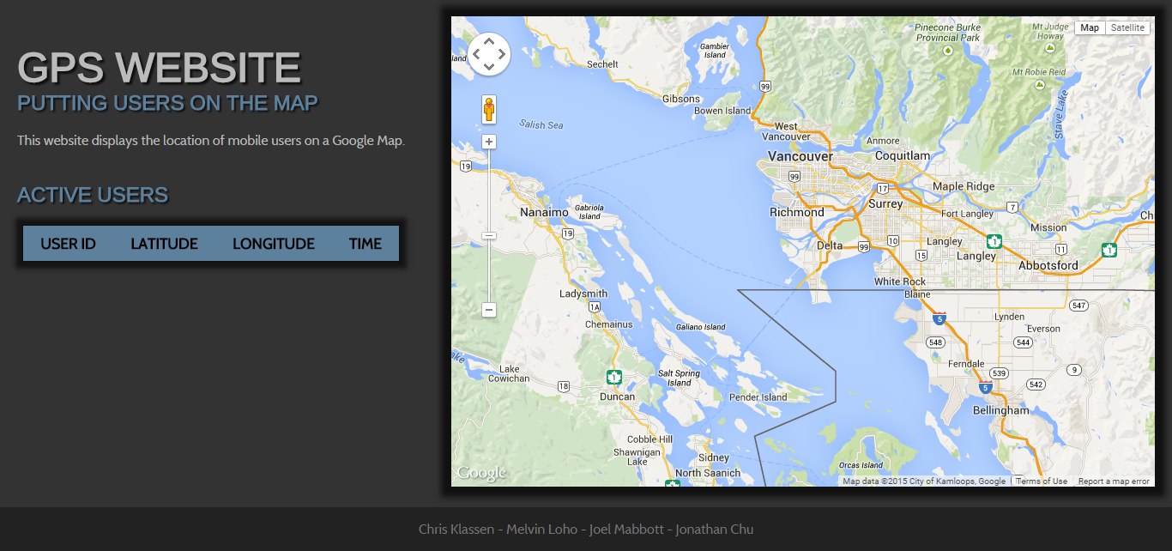

## Using the Website

In order to set the website up, it must first be placed in the file directory that your Apache web server points to. This can be whatever you like, but you must ensure that the website folder in its entirety is placed in the directory.

Once this has been set up, you should be able to access your website over the internet by entering the address of your server.

# The Server

The GPS Server is a Java application that accepts data from all connecting clients, formats, and saves them to a file so that the website can load the data.

## Using the Server

In order to set the server up, the Java application must be built and placed in the same root directory as the website’s index.html file.

Once the server has been built, it should be run using the following format:

**java application_name [port]**

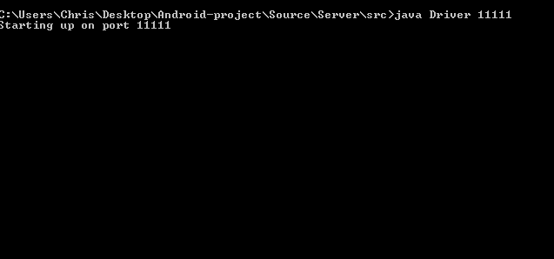

The server will automatically start up and begin waiting for client data. To close the server, press CTRL + C.

If the server is being run from a local server, the port that you are running it on must be properly forwarded to the router.

# The Client

The GPS client is an Android application that uses location services and UDP sockets to send data to a server. This data includes information about the client’s location, id, and the time of the transfer.

## Using the Client

In order to set the client up, the APK must be built and installed on the Android device of your choosing. Once the APK has been installed, the application should be run.

On the main page of the application, you will be prompted for information required to communicate with the server. Enter the server’s IP address, port, and your desired ID.

One the fields have been filled in, press the Connect button to start sending data to the server. This data will be sent every 5 seconds for as long as you remain connected.

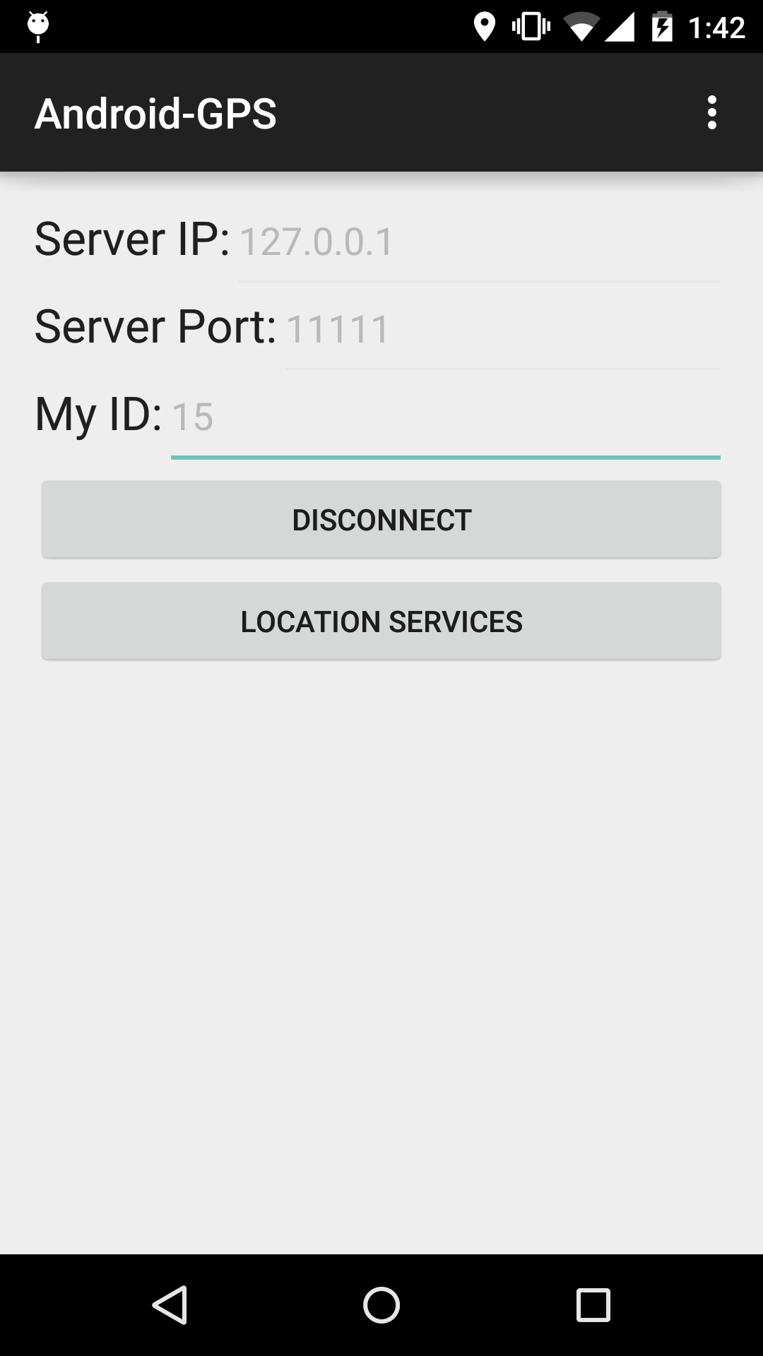

# Conclusion

Once all of these modules have been properly placed and set up, the program should work smoothly. The website will visually represent all the connected clients on the Google Map as pins, and updates every 5 seconds.